**ST. XAVIER’S COLLEGE**

**(Affiliated to Tribhuvan University)**

**Maitighar, Kathmandu**



**COMPUTER GRAPHICS**

**LAB ASSIGNMENT #6**

**Submitted by:**

Hemanchal Joshi

013BSCCSIT021

**Submitted to:**

|  |  |
| --- | --- |
| **Er. Anil K. Sah**  Lecturer  Department of Computer Science |  |

**Date of submission:** 28th August, 2015

**STATEMENT: WAP A PROGRAM TO IMPLEMENT MD-POINT ALGORITHM TO DRAW AN ELLIPSE.**

**ALGORITHM**

**Step 1:** input center (xc,yc) and rx and ry for the ellipse and obtain the first point as (x0,y0)=(0, ry)

**Step 2:** calculate initial decision parameter value in region 1 as

P10=

**Step 3:** at each xk­ position, in region1, starting at k=0, compute

xk+1=xk+1

if p1k=p1k+2xk+1+

yk+1=yk+1

otherwise next point to plot is

yk+1=yk-1

P1k+1=P1k+xk+1+-2yk+1 with xk+1=xk+1 and yk+1=yk-1

**Step 4:** calculate the initial value of decision parameter at region 2 using last calculated point say (x0,y0) in region 1 as

P20=

**Step 5:** at each yk position in region 2 starting at k=0, perform computation

yk+1=y-1

if P2k>0, then

xk+1=xk

P2k+1=P2k-

Otherwise

xk+1=xk+1

P2k+1=P2k+2 where xk+1=xk+1 and yk+1=yk+1

**Step 6**: determine the symmetry points in other three quadrants.

Step 7: move each calculated point (xk,yk) on to the centered (xc,yc) ellipse path as

xk=xk+xc

yk=yk+yc

Step 8: repeat the process for region 1 until and region 2 until (xk,yk)=(rx,0).

**SOURCE CODE:**

//---------------------------------------------------------------------------

#include <vcl\vcl.h>

#pragma hdrstop

#include "ell.h"

//---------------------------------------------------------------------------

#pragma resource "*.dfm"

TForm1 *Form1;

int xc,yc,rx,ry,x,y,p;

//---------------------------------------------------------------------------

__fastcall TForm1::TForm1(TComponent* Owner)

: TForm(Owner)

{

}

//---------------------------------------------------------------------------

void __fastcall TForm1::Button1Click(TObject *Sender)

{

xc=StrToInt(Edit1->Text);

yc=StrToInt(Edit2->Text);

rx=StrToInt(Edit3->Text);

ry=StrToInt(Edit4->Text);

x=0;

y=ry;

p=(ry*ry)-(rx*rx*ry)+((rx*rx)/4);

while((2*x*ry*ry)<(2*y*rx*rx))

{

Image1->Canvas->Pixels[xc+x][yc-y]=RGB(100,125,0);

Image1->Canvas->Pixels[xc-x][yc+y]=RGB(190,1,0);

Image1->Canvas->Pixels[xc+x][yc+y]=RGB(0,25,155);

Image1->Canvas->Pixels[xc-x][yc-y]=RGB(0,15,150);

if(p<0)

{

x=x+1;

p=p+(2*ry*ry*x)+(ry*ry);

}

else

{

x=x+1;

y=y-1;

p=p+(2*ry*ry*x+ry*ry)-(2*rx*rx*y);

}

}

p=((float)x+0.5)*((float)x+0.5)*ry*ry+(y-1)*(y-1)*rx*rx-rx*rx*ry*ry;

while(y>=0)

{

Image1->Canvas->Pixels[xc+x][yc-y]=RGB(0,156,250);

Image1->Canvas->Pixels[xc-x][yc+y]=RGB(250,25,0);

Image1->Canvas->Pixels[xc+x][yc+y]=RGB(125,0,250);

Image1->Canvas->Pixels[xc-x][yc-y]=RGB(90,200,25);

if(p>0)

{

y=y-1;

p=p-(2*rx*rx*y)+(rx*rx);

}

else

{

y=y-1;

x=x+1;

p=p+(2*ry*ry*x)-(2*rx*rx*y)-(rx*rx);

}

}

}

//---------------------------------------------------------------------------

**OUTPUT SCREEN:**

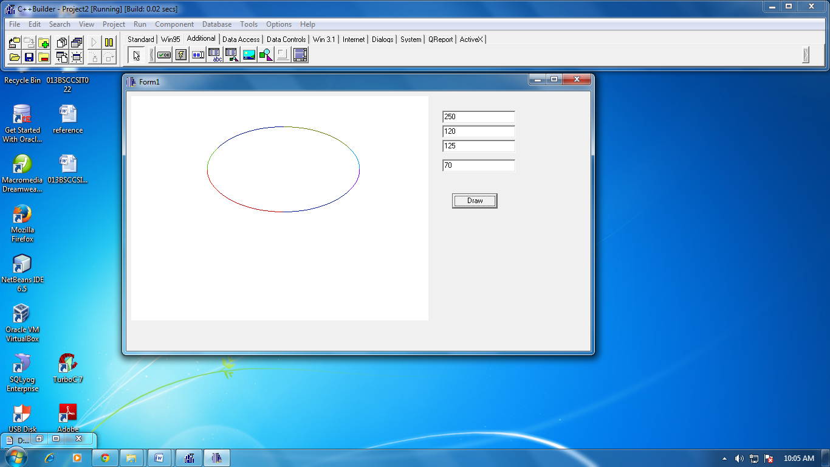

**CONCLUSION:**

Hence, the midpoint algorithm was used to draw an ellipse and we obtained the above results.